QACDG 2020 Day Camp February 11, Tuesday, 9:30 am - noon
The Family Church, 2022 SW 122 St., Gainesville

Teacher: Te Haynes 724-971-3501 mhaynes1000@gmail.com

CLASS: 3 POCKET PURSE

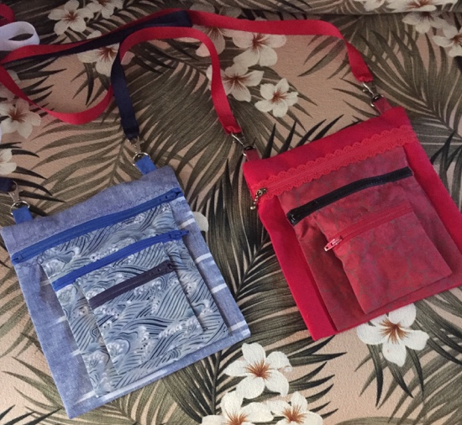

Supply List

Fabric

Front pocket (small) = 8 ¼” x 4 ½”
2” x 4 ½”

Middle pocket (medium) = 12 ½” x 6 ½”
2” x 6 ½”

Back pocket (large) = 15 ¾” x 8 ½”
2” x 8 ½”

Strap = 4” x 30”, cut to preferred length
Alternative = 5/8” x 30” of gross grain ribbon (as pictured)
This streamlines strap assembly and works very well.
You may use 1, 2 or 3 different fabrics. Quilting fabric or slightly thicker fabric will work.

Notions
3 zippers, each larger than width of pocket (4 ½”, 6 ½”, 8 ½”)
They can be trimmed after sewing each pocket.
Gross grain ribbon, 5/8” x 30” for straps, if preferred
2 breakaway clasps for interchangeable straps, if desired (as pictured)

Té Haynes, QACDG, 2019 – pattern created from purchased purse

